Team,

I updated the software after last night’s successful move of the catapult with the pneumatics to simplify the logic in the code for the solenoids. The new logic I added to the Begin.VI looks like:



What is critical here is that the name I use for the devices matches the other places in the code where it appears. Also, the channels for the solenoids need to match the hardware:

The new logic for shooting and returning the catapult look like:

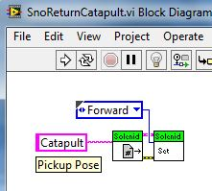 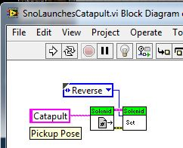

If the buttons are reversed from the desired action, either the tubing connecting the soloenods or the software can change. If the tubing is all looking good I would recommend changing the ‘forward’ and ‘reverse’ settings in the code.

The logic for the gripper stays the same as in the code in the robot.

To use this new code, the team laptop must be connected to the internet, via a cable in the back room, and the google drive folder updated. Then run LabView and ‘build’ the software.

After this, disable the connection to the Internet, and re-enable the wireless connection to the robot. Then the software can be downloaded to the robot with the ‘run as setup’ option.

If the code is modified then the two steps, ‘build’ and ‘run as setup’ need to be repeated to get the new software loaded into the robot.

Felix took some screen shots and is created a document for how to setup the laptop for the IP connections to the outside world and to the robot.